Gamma, Exponential, and Chi-square Distributions

Oliver

## Gamma

We can use the base plot functions in R to create a plot of the pdf for a gamma random variable $X$ with variaous parameters $α$ and $β$. Note that R defines $α=shape$ and $β=scale$— and **scale** = **1/rate**.

x <- seq(0, 10, by=0.001)  
 plot(x, dgamma(x, shape=0.5, scale=0.5), lty=1, col=1, type="l", xlab="x", ylab="f(x)", ylim=c(0,1))  
 lines(x, dgamma(x, shape=1, scale=0.5), lty=2, col=2)  
 lines(x, dgamma(x, shape=2, scale=0.5), lty=3, col=3)  
 lines(x, dgamma(x, shape=0.5, scale=1), lty=4, col=4)  
 lines(x, dgamma(x, shape=1, scale=1), lty=5, col=5)  
 lines(x, dgamma(x, shape=2, scale=1), lty=6, col=6)  
 lines(x, dgamma(x, shape=0.5, scale=2), lty=7, col=7)  
 lines(x, dgamma(x, shape=1, scale=2), lty=8, col=8)  
 lines(x, dgamma(x, shape=2, scale=2), lty=9, col=9)

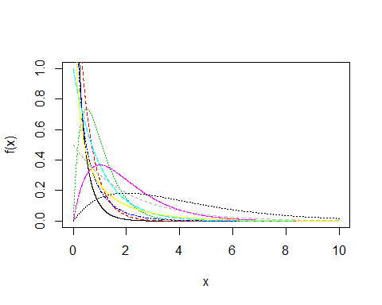

The CDF may be plotted analogously.

x <- seq(0, 10, by=0.001)  
 plot(x, pgamma(x, shape=0.5, scale=0.5), lty=1, col=1, type="l", xlab="x", ylab="F(x)")  
 lines(x, pgamma(x, shape=1, scale=0.5), lty=2, col=2)  
 lines(x, pgamma(x, shape=2, scale=0.5), lty=3, col=3)  
 lines(x, pgamma(x, shape=0.5, scale=1), lty=4, col=4)  
 lines(x, pgamma(x, shape=1, scale=1), lty=5, col=5)  
 lines(x, pgamma(x, shape=2, scale=1), lty=6, col=6)  
 lines(x, pgamma(x, shape=0.5, scale=2), lty=7, col=7)  
 lines(x, pgamma(x, shape=1, scale=2), lty=8, col=8)  
 lines(x, pgamma(x, shape=2, scale=2), lty=9, col=9)

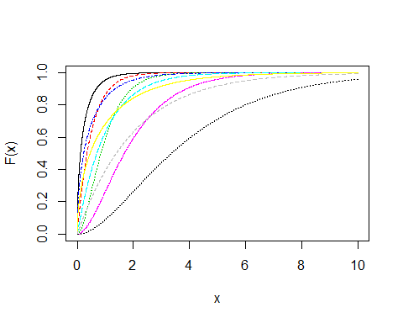

### Exponential

Recall that **rate** = **1/scale**. This is equivalent to $λ=\frac{1}{β}$.

x <- seq(0, 10, by=0.001)  
 plot(x, dexp(x, rate=0.5), lty=1, col=1, type="l", xlab="x", ylab="f(x)", ylim=c(0,2))  
 lines(x, dexp(x, rate=1), lty=2, col=2)  
 lines(x, dexp(x, rate=2), lty=3, col=3)

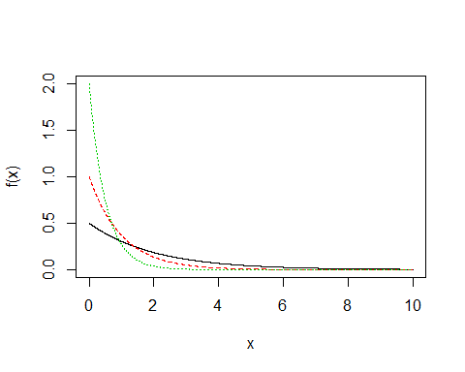

plot(x, pexp(x, rate=0.5), lty=1, col=1, type="l", xlab="x", ylab="F(x)")  
 lines(x, pexp(x, rate=1), lty=2, col=2)  
 lines(x, pexp(x, rate=2), lty=3, col=3)

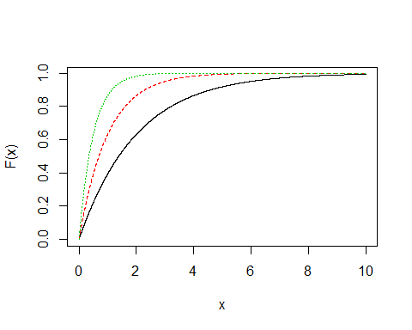

### Chi-Squared

The chi-squared distribution is dependent on the degrees of freedom.

x <- seq(0, 10, by=0.001)  
 plot(x, dchisq(x, df=1), lty=1, col=1, type="l", xlab="x", ylab="f(x)", ylim=c(0,2))  
 lines(x, dchisq(x, df=2), lty=2, col=2)  
 lines(x, dchisq(x, df=5), lty=3, col=3)

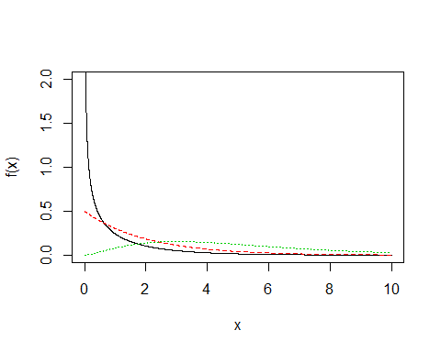

plot(x, pchisq(x, df=1), lty=1, col=1, type="l", xlab="x", ylab="F(x)")  
 lines(x, pchisq(x, df=2), lty=2, col=2)  
 lines(x, pchisq(x, df=5), lty=3, col=3)

